BPV model schooljaar 2019-2020
Klas BG31
Coach: Marjo Anholt

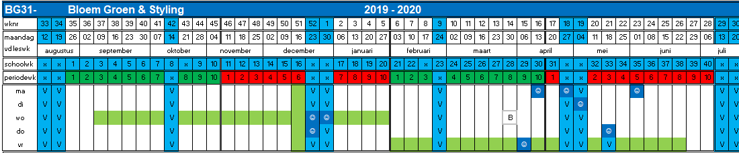

Periode 2:
BPV dag(en) weergegeven in groen
Aantal BPV uren: 128 = 16 dagen
Periode 1
BPV dag(en) aangegeven met groen
Aantal BPV uren: 176 = 22 dagen

